(Approx. 564 words)

Family Tree Maker 2011 (Part 1)
Review by Mary Phillips, Secretary, Icon Users Group, MO
February 2011 issue, The ICON-Newsletter of the Interactive Computer Owners Network
www.iconusersgroup.com
mphillip1.mary (at) gmail.com

Family Tree Maker 2011 has the same seven tabs as 2010 and the family sheets look and work the same. However, a number of updates have been added.

Tab 1 Plan -- Let’s you start a new tree in the program by any of three ways:
1) Entering what you know —begin with yourself),
2) Importing a tree from an existing file — Family Tree Maker (version 5 or newer); a GEDCOM file (GEnealogical Data COMmunication, a standard proposed by the LDS that can be exported from most if not all genealogy programs), Personal Ancestral File (free program that can be downloaded from the LDS website at www.familysearch.org); Legacy Family Tree; or The Master Genealogist.
3) Downloading a tree you’ve created on Ancestry.com.

One addition that I feel is especially important is that when a file is imported, FTM 2011 makes a copy and leaves the original file as it was so it can still be opened in the other program.

The program installs in its own folder and doesn’t remove earlier versions of FTM.

When a tree has been created, a second tab is shown called Current Tree. It shows the person designated as Home Person (usually the person with whom you start, but it can be changed as desired by clicking on the Home Person button and in the Index of Individuals window selecting a different person.

Tab 2 People — two tabs (Family and Person.
The Family tab consists of four panels that can be adjusted by either clicking to open or close a panel, or clicking & dragging to make a panel smaller or larger. The “buttons” to do this are actually series of dots to adjust sizes or eight dots with an arrow in the middle to open or close the left panel or the lower panel. (Note Red Arrows in the picture below.)
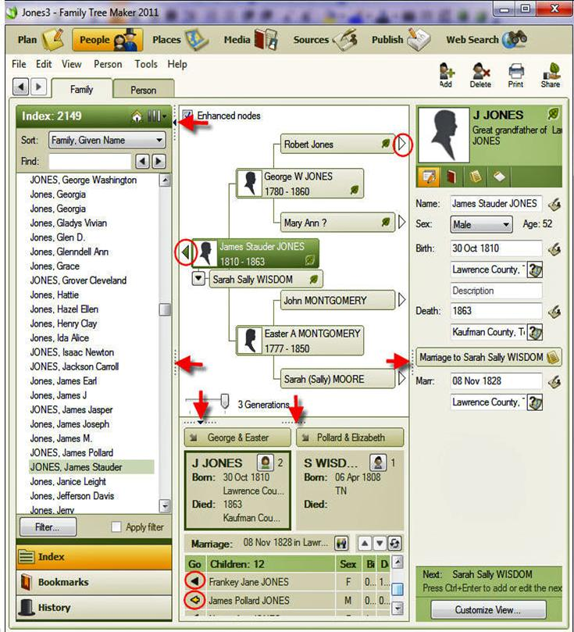

Another feature I especially like is in the upper right corner of the Family tab; the relationship between the person selected and the Home Person is stated. Example: The selected person in the above picture is James Jones and he is the Great Grandfather of La... Jones, the Home Person.

Notice that there are open triangles at the right ends of grandparents of James S Jones (one in circle); open triangles indicate that no additional persons are added on the pedigree chart or that the person had no children. James Jones had children, 12 in fact, so there is a solid triangle to the right of his name (in circle). In the lower panel there is a solid arrow to the right of Frankey Jane showing that she had children. The arrow beside James Pollard has a tail indicating that he is in the direct lineage of La… Jones.

Editing can be done in the right panel fields (boxes) of the Family tab and additional editing in the Person tab. Just below the relationship area are four small icons to enter information for categories: Facts, Media, Notes, and Tasks. Facts are events supported by documents such as Marriage or census records; Media includes photos, videos, audio tapes, scanned letters, etc.; Notes are the family stories, obituaries, newspaper clipping info; and Tasks are a To Do List of items or information needed.



